Advent: Love, Joy, and Peace

Peace – What it is and What it isn’t

Peace on Earth?

Peace in Us?

What Now?

“Peace comes from turning over the outcome to God.”

Advent: Love, Joy, and Peace

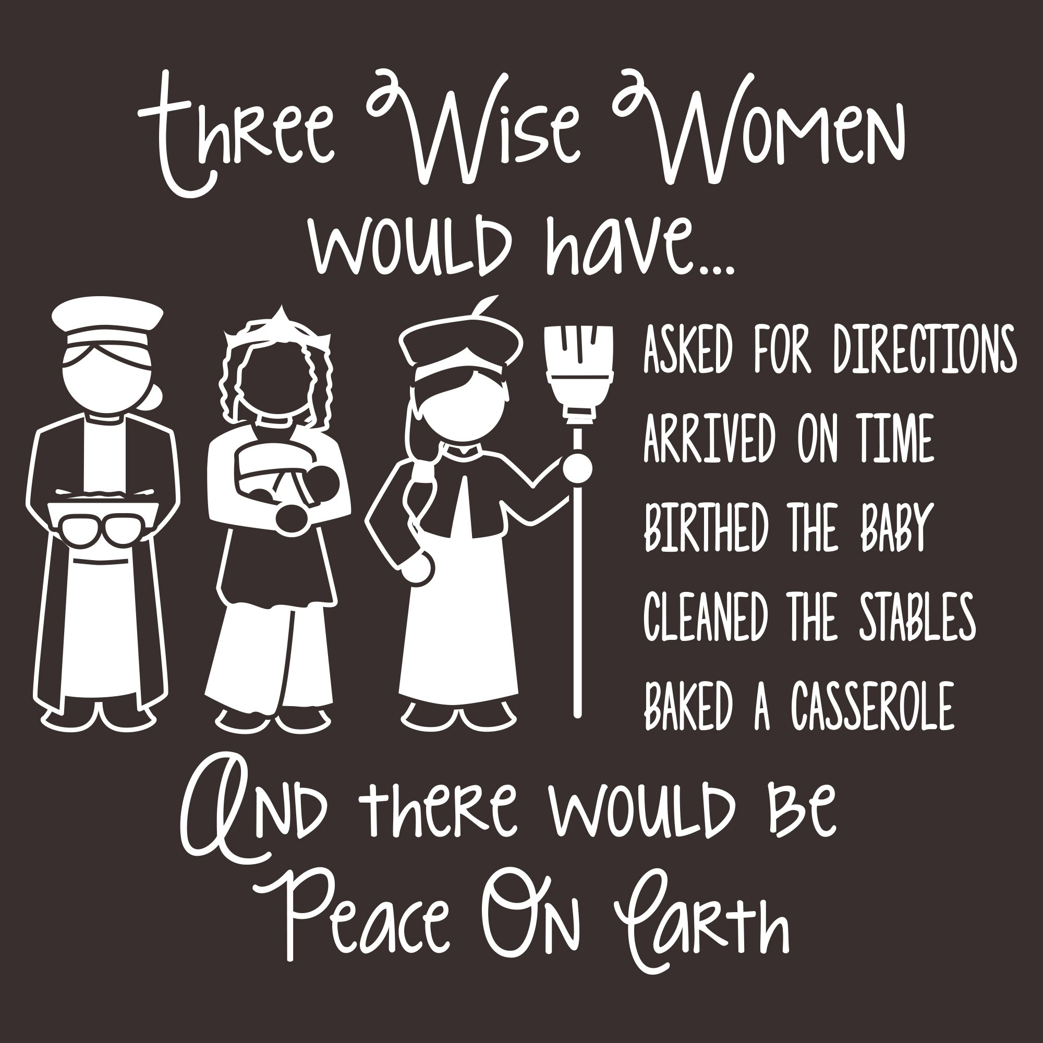

For Further Discussion:
- What activities of the Christmas season make it hardest for you to be at peace? What stresses you most?
- Do you think the source of peace is controlling circumstances, controlling your reaction to circumstances, or to seeing purpose in circumstances?
- How does your faith in Christ affect the way you handle adverse circumstances?

